BABU BANARSI DAS UNIVERSITY

LUCKNOW

SCHOOL OF COMPUTER APPLICATIONS

BCA(CYBER SECURITY & FORENSICS)

3RD SEMESTER



SUBJECT - IDENTITY ACCESS MANAGEMENT

PROJECT TOPIC – **RSA ENCRYPTION & DECRYPTION**

SUBMITTED TO SUBMITTED BY

MR. ANAND KUMAR ANCHAL PANDEY

ROLL NO. – 15

BCACS21

ENCRYPTION & DECRYPTION

Encryption:

Encryption is the process of converting plain text (readable data) into cipher text (unreadable or encoded data) using a mathematical algorithm and an encryption key.

Decryption:

Decryption is the reverse process of encryption. It converts cipher text back into plain text using a decryption key.

Steps to perform image steganography are as follows :-

STEP 1 : Open the Microsoft edge or chrome and search RSA Encryption and decryption.

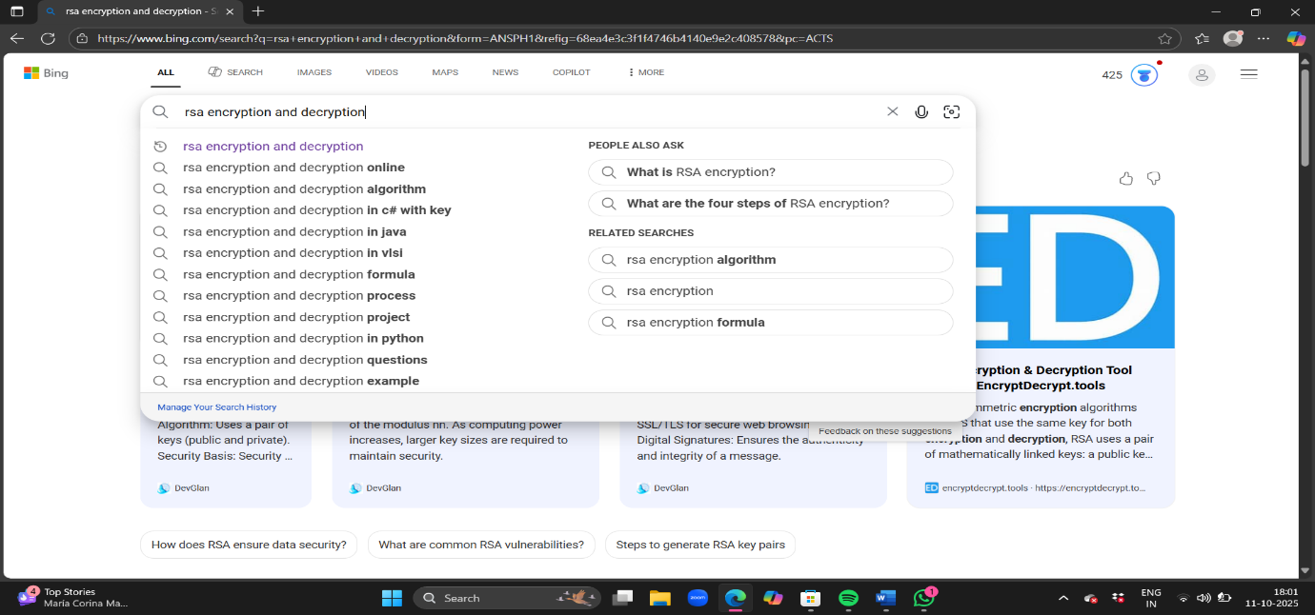

STEP 2 : Click the first website devglan.

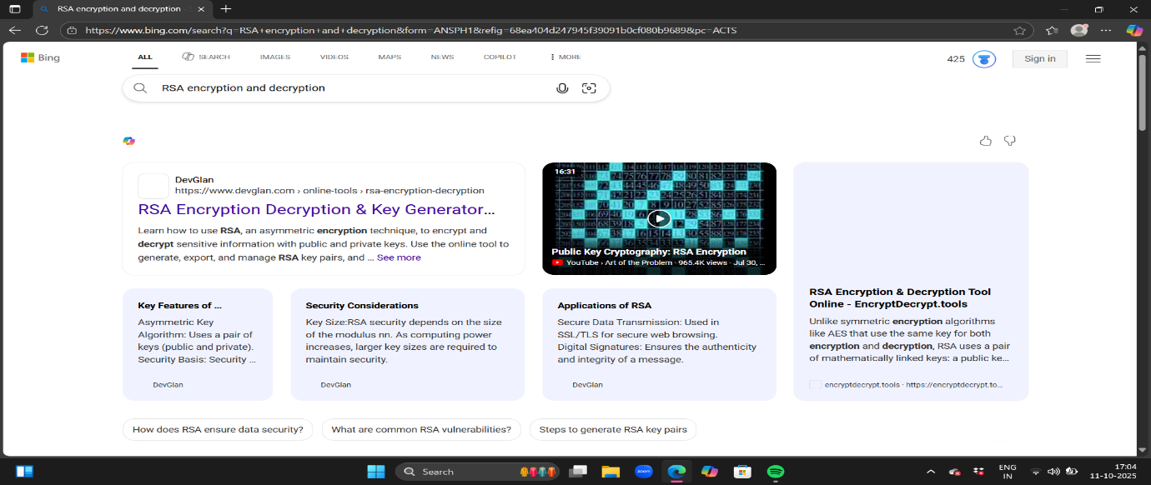

STEP 3 : For generate RSA key pair firstly select key size.

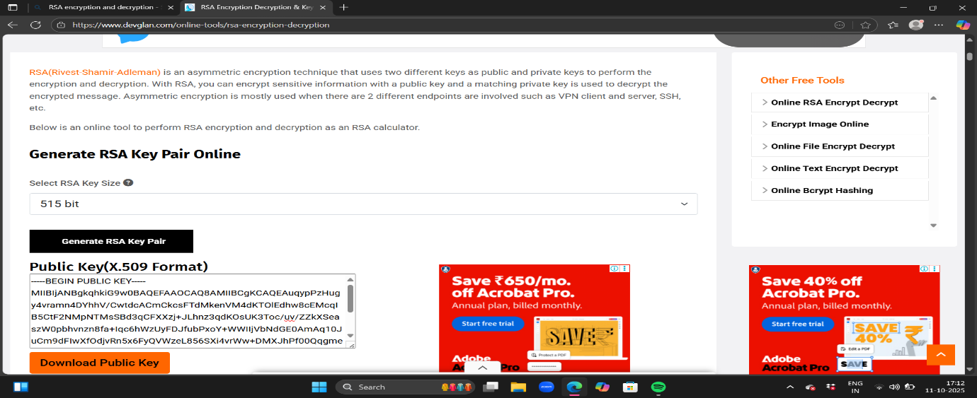

Step 4 : Write a text in the encrypt box for decryption.

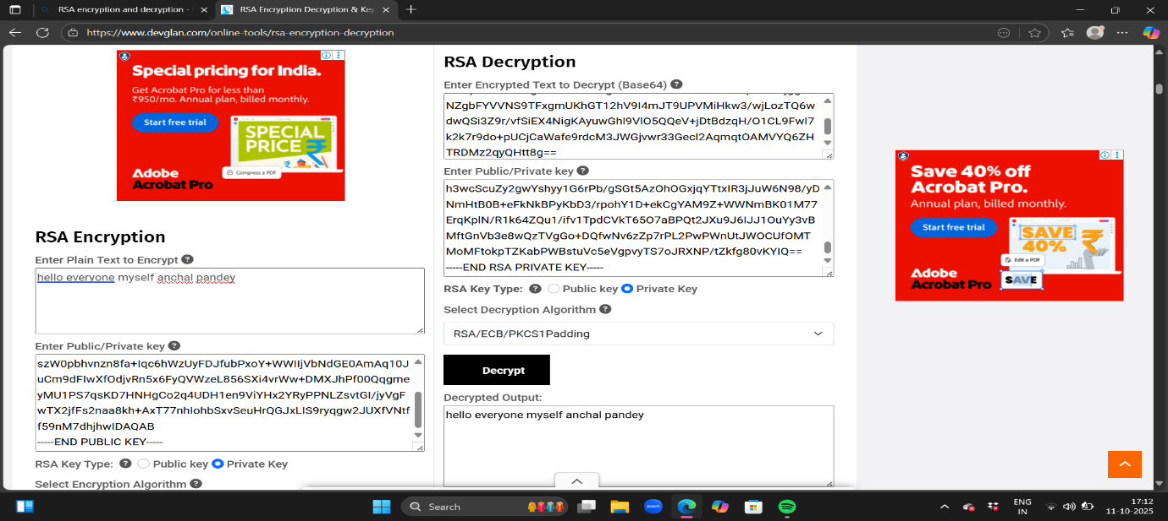

STEP 5: Here the massage was encrypt into private key. And for decrypt the massage you specially copy the encrypt msg and paste in decrypt box.

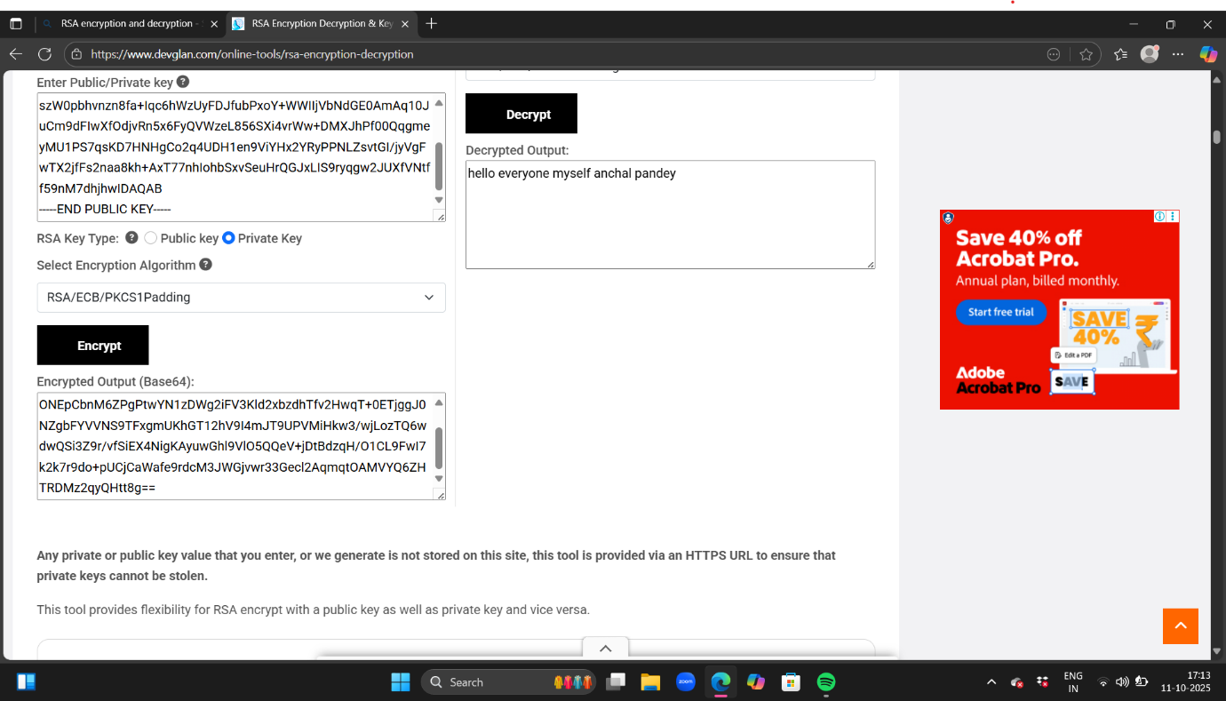

STEP 6 : This process going on then you change the bit pair for encryption.

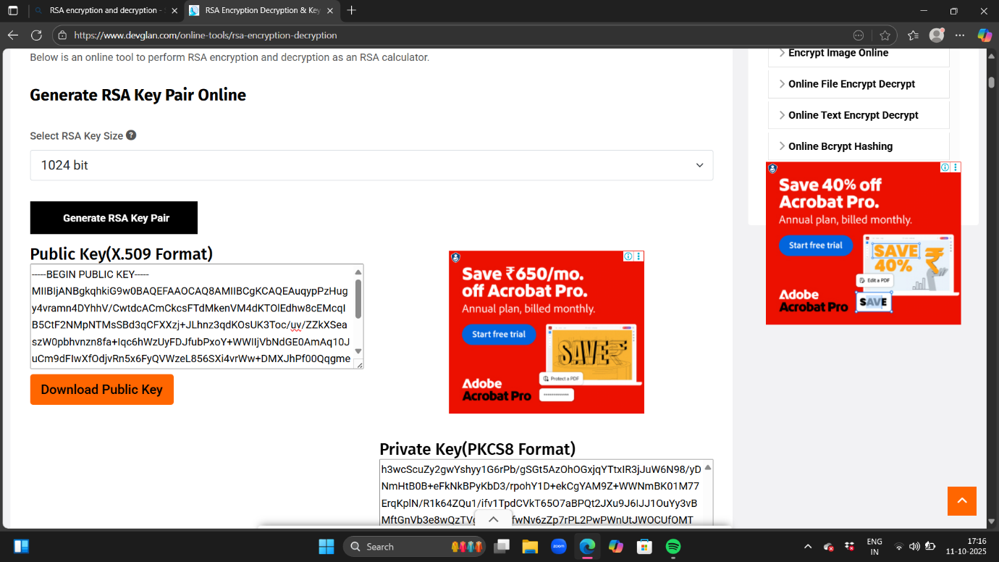

STEP 7 : Again we write a massage for encryption & this time because of the bit the encrypt massage length is long.

